**Hiring Process Analytics**

###### Description:

Imagine you're a data analyst at a multinational company like Google. Your task is to analyze the company's hiring process data and draw meaningful insights from it. The hiring process is a crucial function of any company, and understanding trends such as the number of rejections, interviews, job types, and vacancies can provide valuable insights for the hiring department.  
  
As a data analyst, you'll be given a dataset containing records of previous hires. Your job is to analyze this data and answer certain questions that can help the company improve its hiring process.  
  
Here's what you'll be doing:

1. **Handling Missing Data:** Check if there are any missing values in the dataset. If there are, decide on the best strategy to handle them.
2. **Clubbing Columns:** If there are columns with multiple categories that can be combined, do so to simplify your analysis.
3. **Outlier Detection:** Check for outliers in the dataset that may skew your analysis.
4. **Removing Outliers:** Decide on the best strategy to handle outliers. This could be removing them, replacing them, or leaving them as is, depending on the situation.
5. **Data Summary:** After cleaning and preparing your data, summarize your findings. This could involve calculating averages, medians, or other statistical measures. It could also involve creating visualizations to better understand the data.

###### Data Analytics Tasks:

**A. Hiring Analysis:** The hiring process involves bringing new individuals into the organization for various roles.

**Your Task:** Determine the gender distribution of hires. How many males and females have been hired by the company?

**B. Salary Analysis:** The average salary is calculated by adding up the salaries of a group of employees and then dividing the total by the number of employees.

**Your Task:** What is the average salary offered by this company? Use Excel functions to calculate this.

**C. Salary Distribution:** Class intervals represent ranges of values, in this case, salary ranges. The class interval is the difference between the upper and lower limits of a class.

**Your Task:** Create class intervals for the salaries in the company. This will help you understand the salary distribution.

**D. Departmental Analysis:** Visualizing data through charts and plots is a crucial part of data analysis.

**Your Task:** Use a pie chart, bar graph, or any other suitable visualization to show the proportion of people working in different departments.

**E. Position Tier Analysis:** Different positions within a company often have different tiers or levels.

**Your Task:** Use a chart or graph to represent the different position tiers within the company. This will help you understand the distribution of positions across different tiers.

**Hiring Analysis:** The hiring process involves bringing new individuals into the organization for various roles.

**Your Task:** Determine the gender distribution of hires. How many males and females have been hired by the company?

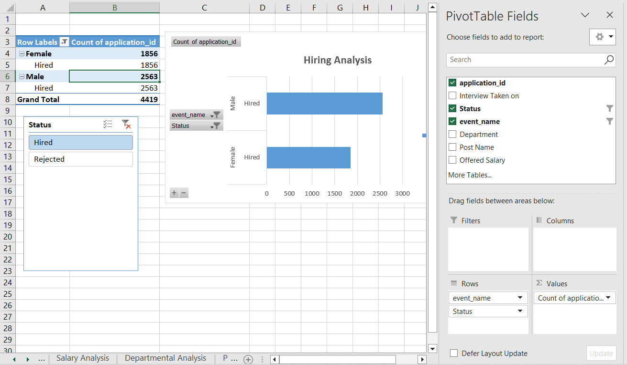

**Salary Analysis:** The average salary is calculated by adding up the salaries of a group of employees and then dividing the total by the number of employees.

**Your Task:** What is the average salary offered by this company? Use Excel functions to calculate this.

To find the average salary offered in this company:

1. First, we need to remove the outliers

**First Quartile** = Quartile.EXE(offered salary , 1)

**Third Quartile =** Quartile.EXE(offered salary,2)

**IQR** = Third Quartile - First Quartile

2. Then using the formula =AVERAGE(entire_column_of_salary_after_removing_outliers)

|  |  |
| --- | --- |
| **First Quartile** | 25450.25 |
| **Third Quartile** | 74408.25 |
| **IQR** | 48958 |
|  |  |
| **Upper bound** | 147845.25 |
| **Lower bound** | -47986.75 |
|  |  |
| **Average salary** | 49878.332 |
|  |  |
| **Max** | 99967 |
| **Min** | 100 |

**Salary Distribution:** Class intervals represent ranges of values, in this case, salary ranges. The class interval is the difference between the upper and lower limits of a class.

**Your Task:** Create class intervals for the salaries in the company. This will help you understand the salary distribution.

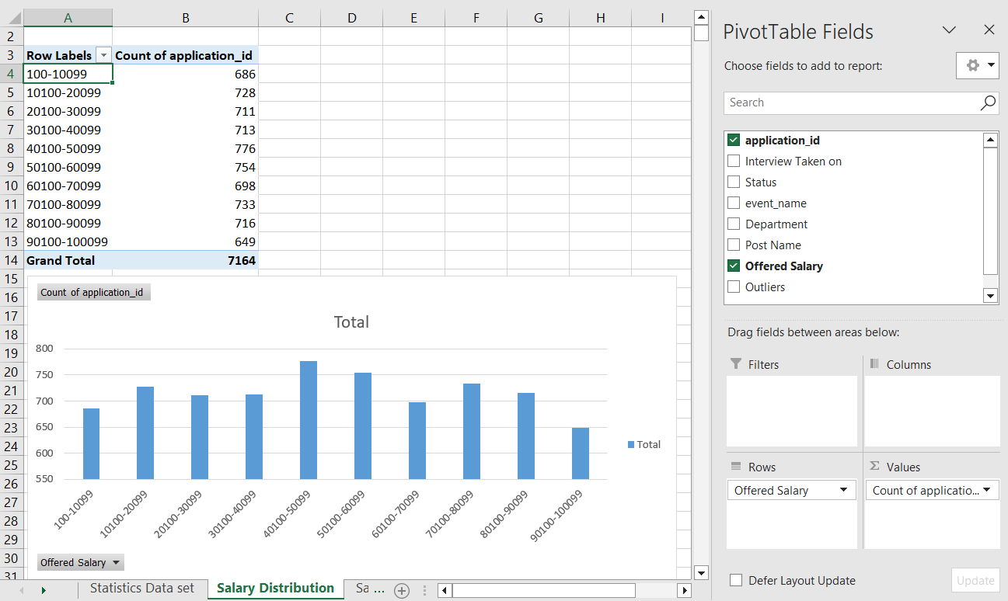

**Departmental Analysis:** Visualizing data through charts and plots is a crucial part of data analysis.

**Your Task:** Use a pie chart, bar graph, or any other suitable visualization to show the proportion of people working in different departments.

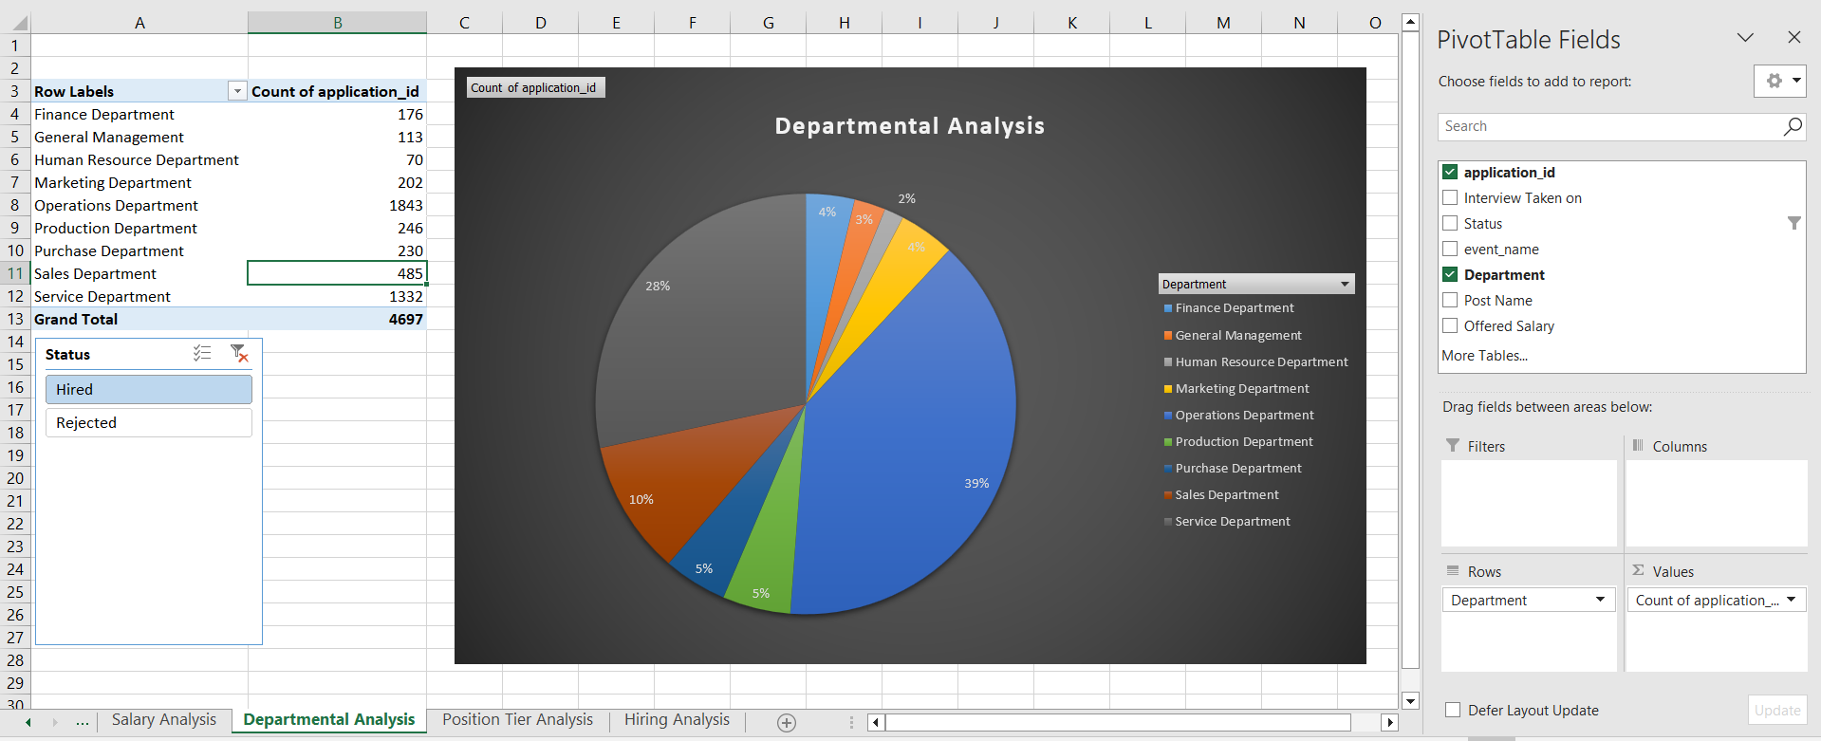

**Position Tier Analysis:** Different positions within a company often have different tiers or levels.

**Your Task:** Use a chart or graph to represent the different position tiers within the company. This will help you understand the distribution of positions across different tiers.

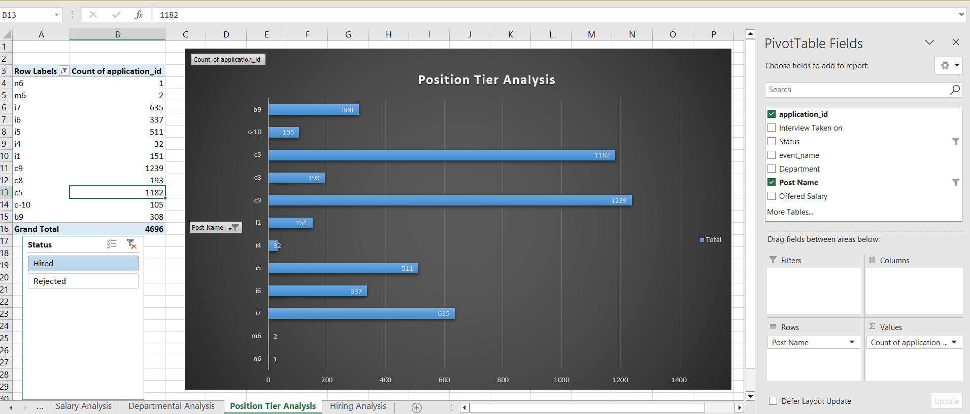



D:\Tranity\assignments\Hiring Process Analytics.xlsx

https://docs.google.com/spreadsheets/d/1CfxtvUJGeTXp38qAnQKr3Aghdve8uzMG/edit?usp=sharing&ouid=109690823837991827030&rtpof=true&sd=true